**Experiment No: 3**

Aim: Interfacing with Arduino uno - Buzzer, potentiometer, LED, Switch, Resistors

Objective:

1. Alternately turn ON / OFF the BUZZER

void setup()

{

pinMode(9, OUTPUT);

}

void loop()

{

tone(9,440);

delay(1000);

noTone(9);

delay(1000);

}

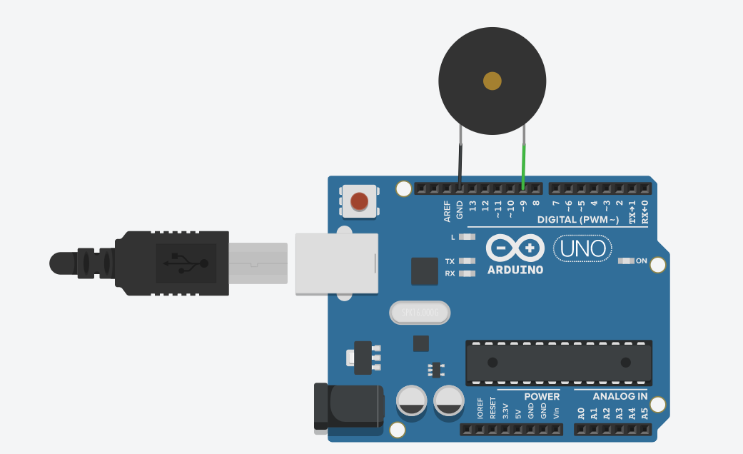

Schematic Diagram:

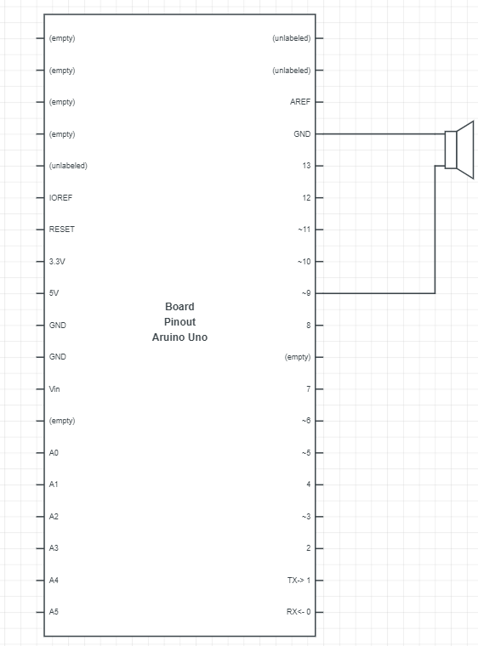

1. Blink LED without using delay

int ledState = LOW;

unsigned long previous_time = 0;

void setup()

{

pinMode(13, OUTPUT);

}

void loop()

{

unsigned long current_time = millis();

//taking interval between blinks as 1000

if (current_time - previous_time >= 1000)

{

previous_time = current_time;

if (ledState == LOW)

{

ledState = HIGH;

}

else

{

ledState = LOW;

}

digitalWrite(13, ledState);

}

}

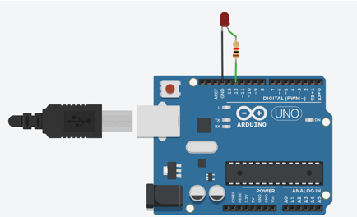

1. Demonstrate the use of input pull

**int buttonState = 0;**

**void setup()**

**{**

**pinMode(8, OUTPUT);**

**pinMode(3, INPUT_PULLUP);**

**Serial.begin(9600);**

**}**

**void loop()**

**{**

**buttonState = digitalRead(3);**

**Serial.println(buttonState);**

**delay(1000);**

**if (buttonState == HIGH)**

**{**

**digitalWrite(8, HIGH);**

**}**

**if (buttonState == LOW)**

**{**

**digitalWrite(8, LOW);**

**}**

**}**

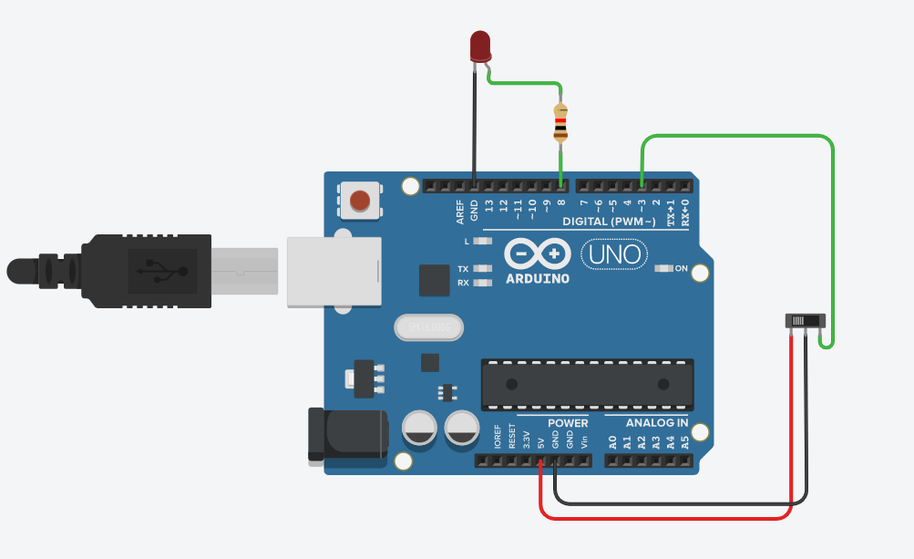

1. Traffic signal using RGB

void setup()

{

pinMode(12,OUTPUT);

pinMode(10,OUTPUT);

pinMode(8,OUTPUT);

}

void loop()

{

analogWrite(12, 255);

analogWrite(10, 0);

analogWrite(8, 0);

delay(1000);

analogWrite(12, 255);

analogWrite(10, 0);

analogWrite(8, 255);

delay(1000);

analogWrite(12, 0);

analogWrite(10, 0);

analogWrite(8, 255);

delay(1000);

}

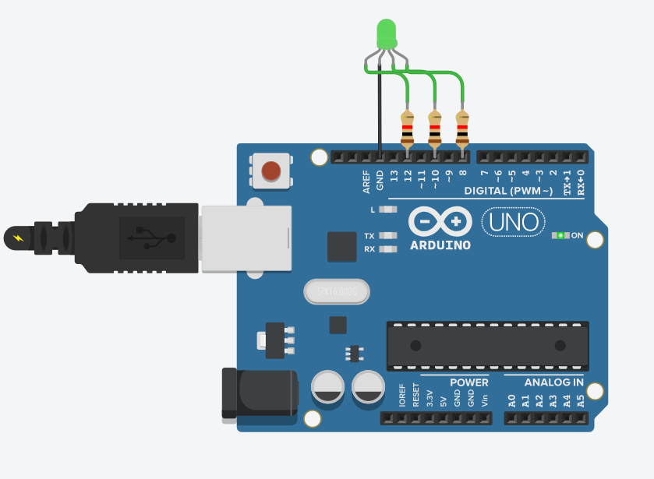

1. Control tone of buzzer with potentiometer

int val = 0;

void setup()

{

pinMode(9, OUTPUT);

pinMode(A0, INPUT);

}

void loop()

{

val = analogRead(A0);

tone(9,map(val,0,1023,120,1500));

Serial.println("\n");

Serial.println(val);

delay(2);

}

Snap:

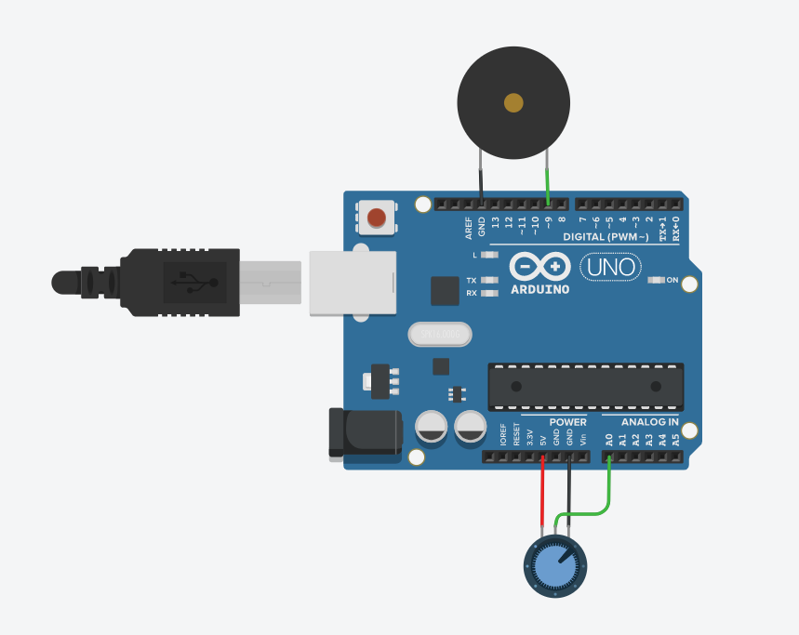

1. Play a tune when button is pressed

int buttonState = 0;

int melody[]={262,196,196,220,196,0,247,262};

int duration[]={250,125,125,250,250,250,250,250};

void setup()

{

pinMode(2, INPUT);

pinMode(9, OUTPUT);

}

void loop()

{

buttonState = digitalRead(2);

if(buttonState==HIGH)

{

for(int i=0;i<=7;i++)

{

tone(9,melody[i],duration[i]);

delay(duration[i]*1.5);

noTone(9);

}

}

}

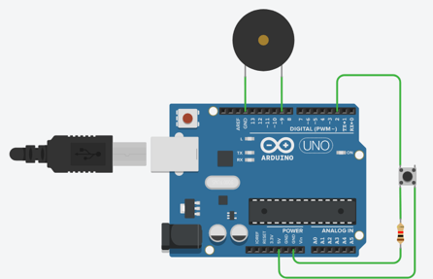

1. Traffic signal with a buzzer

void setup()

{

pinMode(2, OUTPUT);

pinMode(3, OUTPUT);

pinMode(4, OUTPUT);

pinMode(5, OUTPUT);

}

void loop()

{

digitalWrite(2, HIGH);

delay(3000);

tone(5, 440);

delay(2000);

noTone(5);

digitalWrite(2, LOW);

for(int i=0;i<5;i++)

{

digitalWrite(3, HIGH);

delay(500);

digitalWrite(3, LOW);

delay(500);

}

digitalWrite(3, LOW);

digitalWrite(4, HIGH);

delay(3000);

tone(5, 440);

delay(2000);

noTone(5);

digitalWrite(4, LOW);

}

Snap:

